Contribution Title
Henry Van Boskir11 and Zachary Debler1 and Ryan Gilbert1
¹ University of Florida, Gainesville FL 32603, USA
Abstract. The paper will analyze plant images taken by citizen science plant photographers as well as ancillary variables such as climate, soil, and multitemporal satellite variables using deep learning-based regression models, such as Convolutional Neural Networks to predict key traits among plants. Stem Specific Density, Leaf Area Per Leaf Dry Mass, Plant Height, Seed Dry Mass, Leaf Nitrogen, and Leaf Area are the relevant traits to be predicted.
The Kaggle Competition we have chosen aims to use deep learning to make predictions on these six traits. As a baseline, we submitted totally random predictions. We increasingly used more complex models, next with a linear regression model on just the datatable of ancillary variables. Our team also tried gradient boosted trees as well as random forest regression in order to make better predictions. These models do not take into account the citizen science plant photographs at all, however.
For our final models, we transitioned to the most complex models of our project: Convolutional Neural Networks (CNNs). We used the PyTorch framework and its documentation to create models. We adjusted hyperparameters like number of epochs, batch size, learning rate, and depth of the neural network to increase the accuracy of our predictions..
Keywords: First Keyword, Second Keyword, Third Keyword.
- Introduction
Plant traits are plant properties that are used to describe how plants function and how they interact with the environment.

  - Project Goal
Plant traits are plant properties that are used to describe how plants function and how they interact with the environment

Listed below are the plant traits that we will be predicting using our model. These traits allow researchers to understand the ability of plants to adapt to environmental conditions as well as manage the responses of plant communities to environmental change to conserve biodiversity in natural ecosystems.

Table 1. Plant Traits
Plant Traits | Definition | Significance
Stem Specific Density | Density or mass per unit volume of the stem tissue of a plant | Assessing forest health.
Leaf Area Per Dry Leaf Mass | Relationship between the surface area of a leaf and its dry weight | Higher drought tolerance, longer leaf lifespan, and lower photosynthetic capacity per unit area
Plant Height | Height of plant | Predicting and managing the responses of plant communities to environmental change
Seed Dry Mass | Refers to the weight or mass of a seed after it has undergone desiccation or drying | Influences plant fitness, population dynamics, community structure
Leaf Nitrogen | Concentration of nitrogen present in the leaves of a plant | Fundamental roles in plant growth, photosynthesis, nutrient cycling
Leaf Area | Total surface area of a leaf exposed to light and the surrounding environment | Crucial for plant photosynthesis, resource capture, and plant growth.
Displayed equations are centered and set on a separate line.
x + y = z (1)
Please try to avoid rasterized images for line-art diagrams and schemas. Whenever possible, use vector graphics instead (see Fig. 1).

Fig. 1. A figure caption is always placed below the illustration. Short captions are centered, while long ones are justified. The macro button chooses the correct format automatically.
For citations of references, we prefer the use of square brackets and consecutive numbers. Citations using labels or the author/year convention are also acceptable. The following bibliography provides a sample reference list with entries for journal articles [1], an LNCS chapter [2], a book [3], proceedings without editors [4], as well as a URL [5].
Acknowledgments. A third level heading in 9-point font size at the end of the paper is used for general acknowledgments, for example: This study was funded by X (grant number Y).
Disclosure of Interests. It is now necessary to declare any competing interests or to specifically state that the authors have no competing interests. Please place the statement with a third level heading in 9-point font size beneath the (optional) acknowledgments, for example: The authors have no competing interests to declare that are relevant to the content of this article. Or: Author A has received research grants from Company W. Author B has received a speaker honorarium from Company X and owns stock in Company Y. Author C is a member of committee Z.

- Data Sources
The data provided for analysis includes thousands of photographs from thousands of citizens around the globe. With species identification apps, and AI algorithms, the species are identified and given in the data. The data of the plants cover all ecosystem types and continents and encompass an enormous array of species.

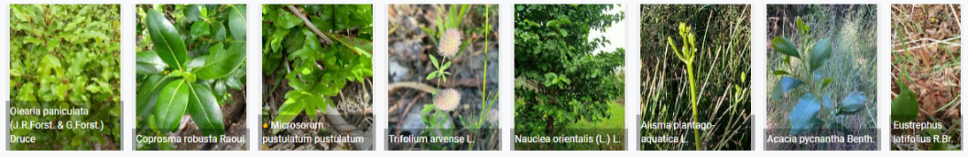
Fig. 2. Samples of the images included in the dataset can be visualized above. Their species is outlined in the print at the bottom of each image. [2]

- Methods/Models
  - Types of Models Employed

Linear Regression Models

Random Forest Models

Random forests are key for training and testing data. Ensuring that the distribution is balanced across a random sample helps to identify color, texture, and shape features from images along with deep neural networks.

Neural Networks

The applications of Convolution Neural Networks (CNN) are vast, however their ability to detect spatial dependencies in data make their usage very effective for image processing.

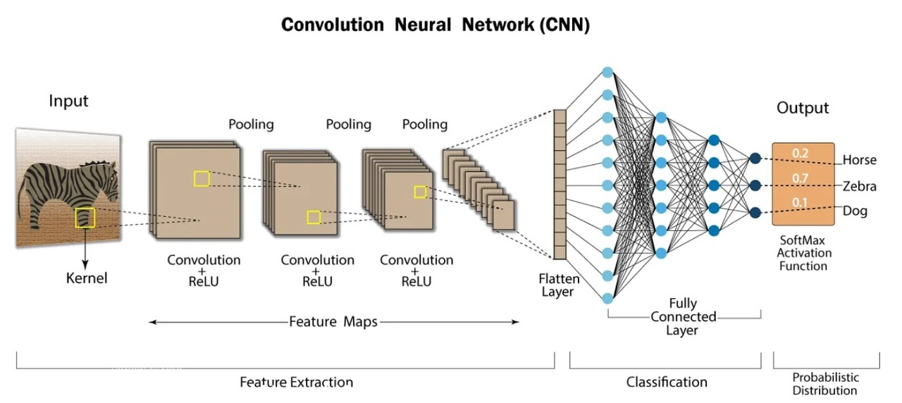
Fig. 3. Depicted above is a sample Convolutional Neural Network outlining its ability to extract and classify features of certain images. [1]
The range of images that CNN can process is particularly useful in this case where many of the plant images are wide in variety. Taken from a multitude of sources, these images are taken from different angles, with and without color and are a different shapes and sizes. Overcoming these obstacles is plausible by means of these neural networks.

- Technical Assessment of Future Work

Attributions
- https://www.google.com/url?sa=i&url=https%3A%2F%2Fwww.linkedin.com%2Fpulse%2Fwhat-convolutional-neural-network-cnn-deep-learning-nafiz-shahriar&psig=AOvVaw0_yVXbVLa9qhjd5XolygK9&ust=1714351244728000&source=images&cd=vfe&opi=89978449&ved=0CBQQjhxqFwoTCLDphpvW44UDFQAAAAAdAAAAABAJ
- https://www.kaggle.com/competitions/planttraits2024/overview
- Author, F.: Article title. Journal 2(5), 99–110 (2016)
- Author, F., Author, S.: Title of a proceedings paper. In: Editor, F., Editor, S. (eds.) CONFERENCE 2016, LNCS, vol. 9999, pp. 1–13. Springer, Heidelberg (2016)
- Author, F., Author, S., Author, T.: Book title. 2nd edn. Publisher, Location (1999)
- Author, F.: Contribution title. In: 9th International Proceedings on Proceedings, pp. 1–2. Publisher, Location (2010)
- LNCS Homepage, http://www.springer.com/lncs, last accessed 2023/10/25

If EquinOCS, our proceedings submission system, is used, then the disclaimer can be provided directly in the system.

